Computer Organization and Assembly Language

|  |  |
| --- | --- |
| **Lab 06** | |
| **Topic** | * Arithmetic & Logical instructions * Selective bit setting/clearing/complimenting * Shifting and Rotations variations * Extended addition and subtraction |

***Part 1***

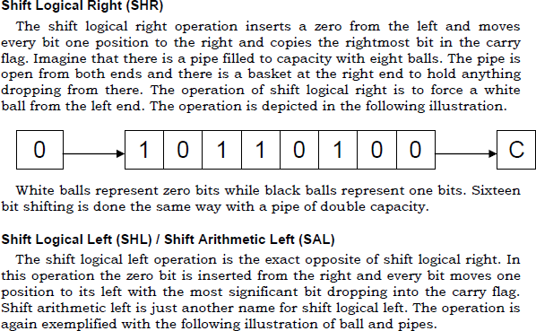

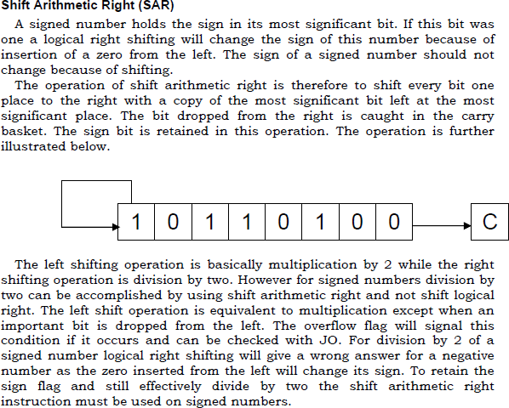

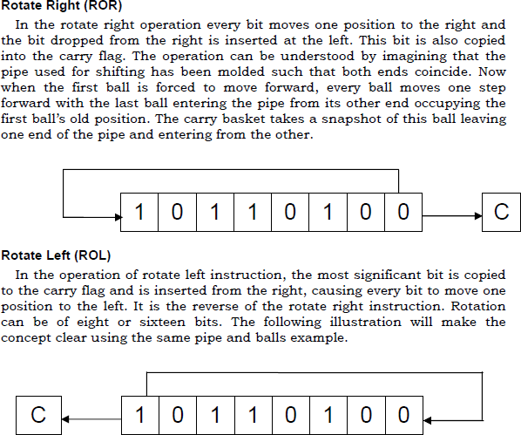

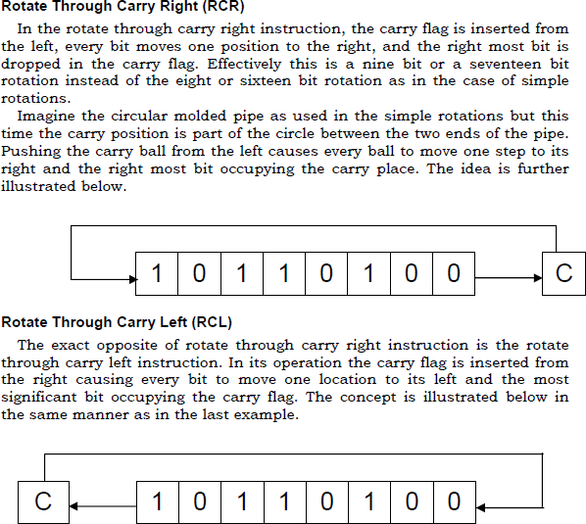

# Example 1:

Multiply the number by 4 using shift operator.

Let the number is 5 and also apply all shift operation shr ,sal,and sar ect .



# Example 2:

Rotate right 3 times the value in register bx and also apply all shift operation rol,rcr and rcl ect.

Let BX=0xEFCD



**Q1.** Declare a byte type array of 10 element then write a program to count odd and even numbers in array and store count in a variable “countEven” and “countOdd”. Implement this problem without updating the actual values of the array elements. Do not make another array.

Note: use logical operations only

|  |  |  |  |  |  |  |  |  |  |  |
| --- | --- | --- | --- | --- | --- | --- | --- | --- | --- | --- |
| **Index** | **0** | **1** | **2** | **3** | **4** | **5** | **6** | **7** | **8** | **9** |
| **Value** | 0xAB | 0x7E | 0xAB | 0xED | 0x4B | 0x44 | 0xAA | 0xCC | 0x12 | 0xEE |

**Q2.** Write an assembly language program to count the number of ones in register ax. Let

value in ax is 0xABCD